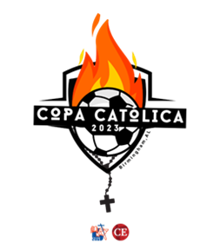

**Individual Team Participant Profile**

Individual leader participant information to be collected by Team leaders and forwarded to Diocesan Young Adult / Hispanic Ministry Directors for the Team application. Diocesan directors: Please submit to CE’s primary diocesan contact, who will need to fill these fields for each team member.

***Diocesan Young Adult /Hispanic Ministry Directors:*** Each team must be composed of **invited young adult leaders** who are active in an extension diocese, at the parish or diocesan level.

**Team Name:**

**Team Leader:**

***Invited participants:*** Please provide **a brief bio** about yourself in a few sentences, and answer the questions below:

**Short biography:**

1. **Name:**

2. **Parish:**

3. **Ministry:**

4. **Diocese:**

5**. Email:**

6. **Telephone:**

**7. MINISTRY:** What ministry are you currently, or have been, involved in, and at which level?

**9. PARISH:** Name of parish/number of families/parishioners that it serves? Number of young adults it serves. Primary ethnic group served, if applicable.

**10. GOAL(S):** What are your long-term service goals in their parish/diocese and the Church overall?

**11. Metrics:** How will you measure your success?

**12.** **Mission in Action:** If your team wins the Copa Católica, how will you apply the $2,000 winner stipend to your ministry?